The Society of Women Writers NSW Inc.
Giving Women Writers a Voice
Patron: Emeritus Professor Di Yerbury
www.womenwriters.org

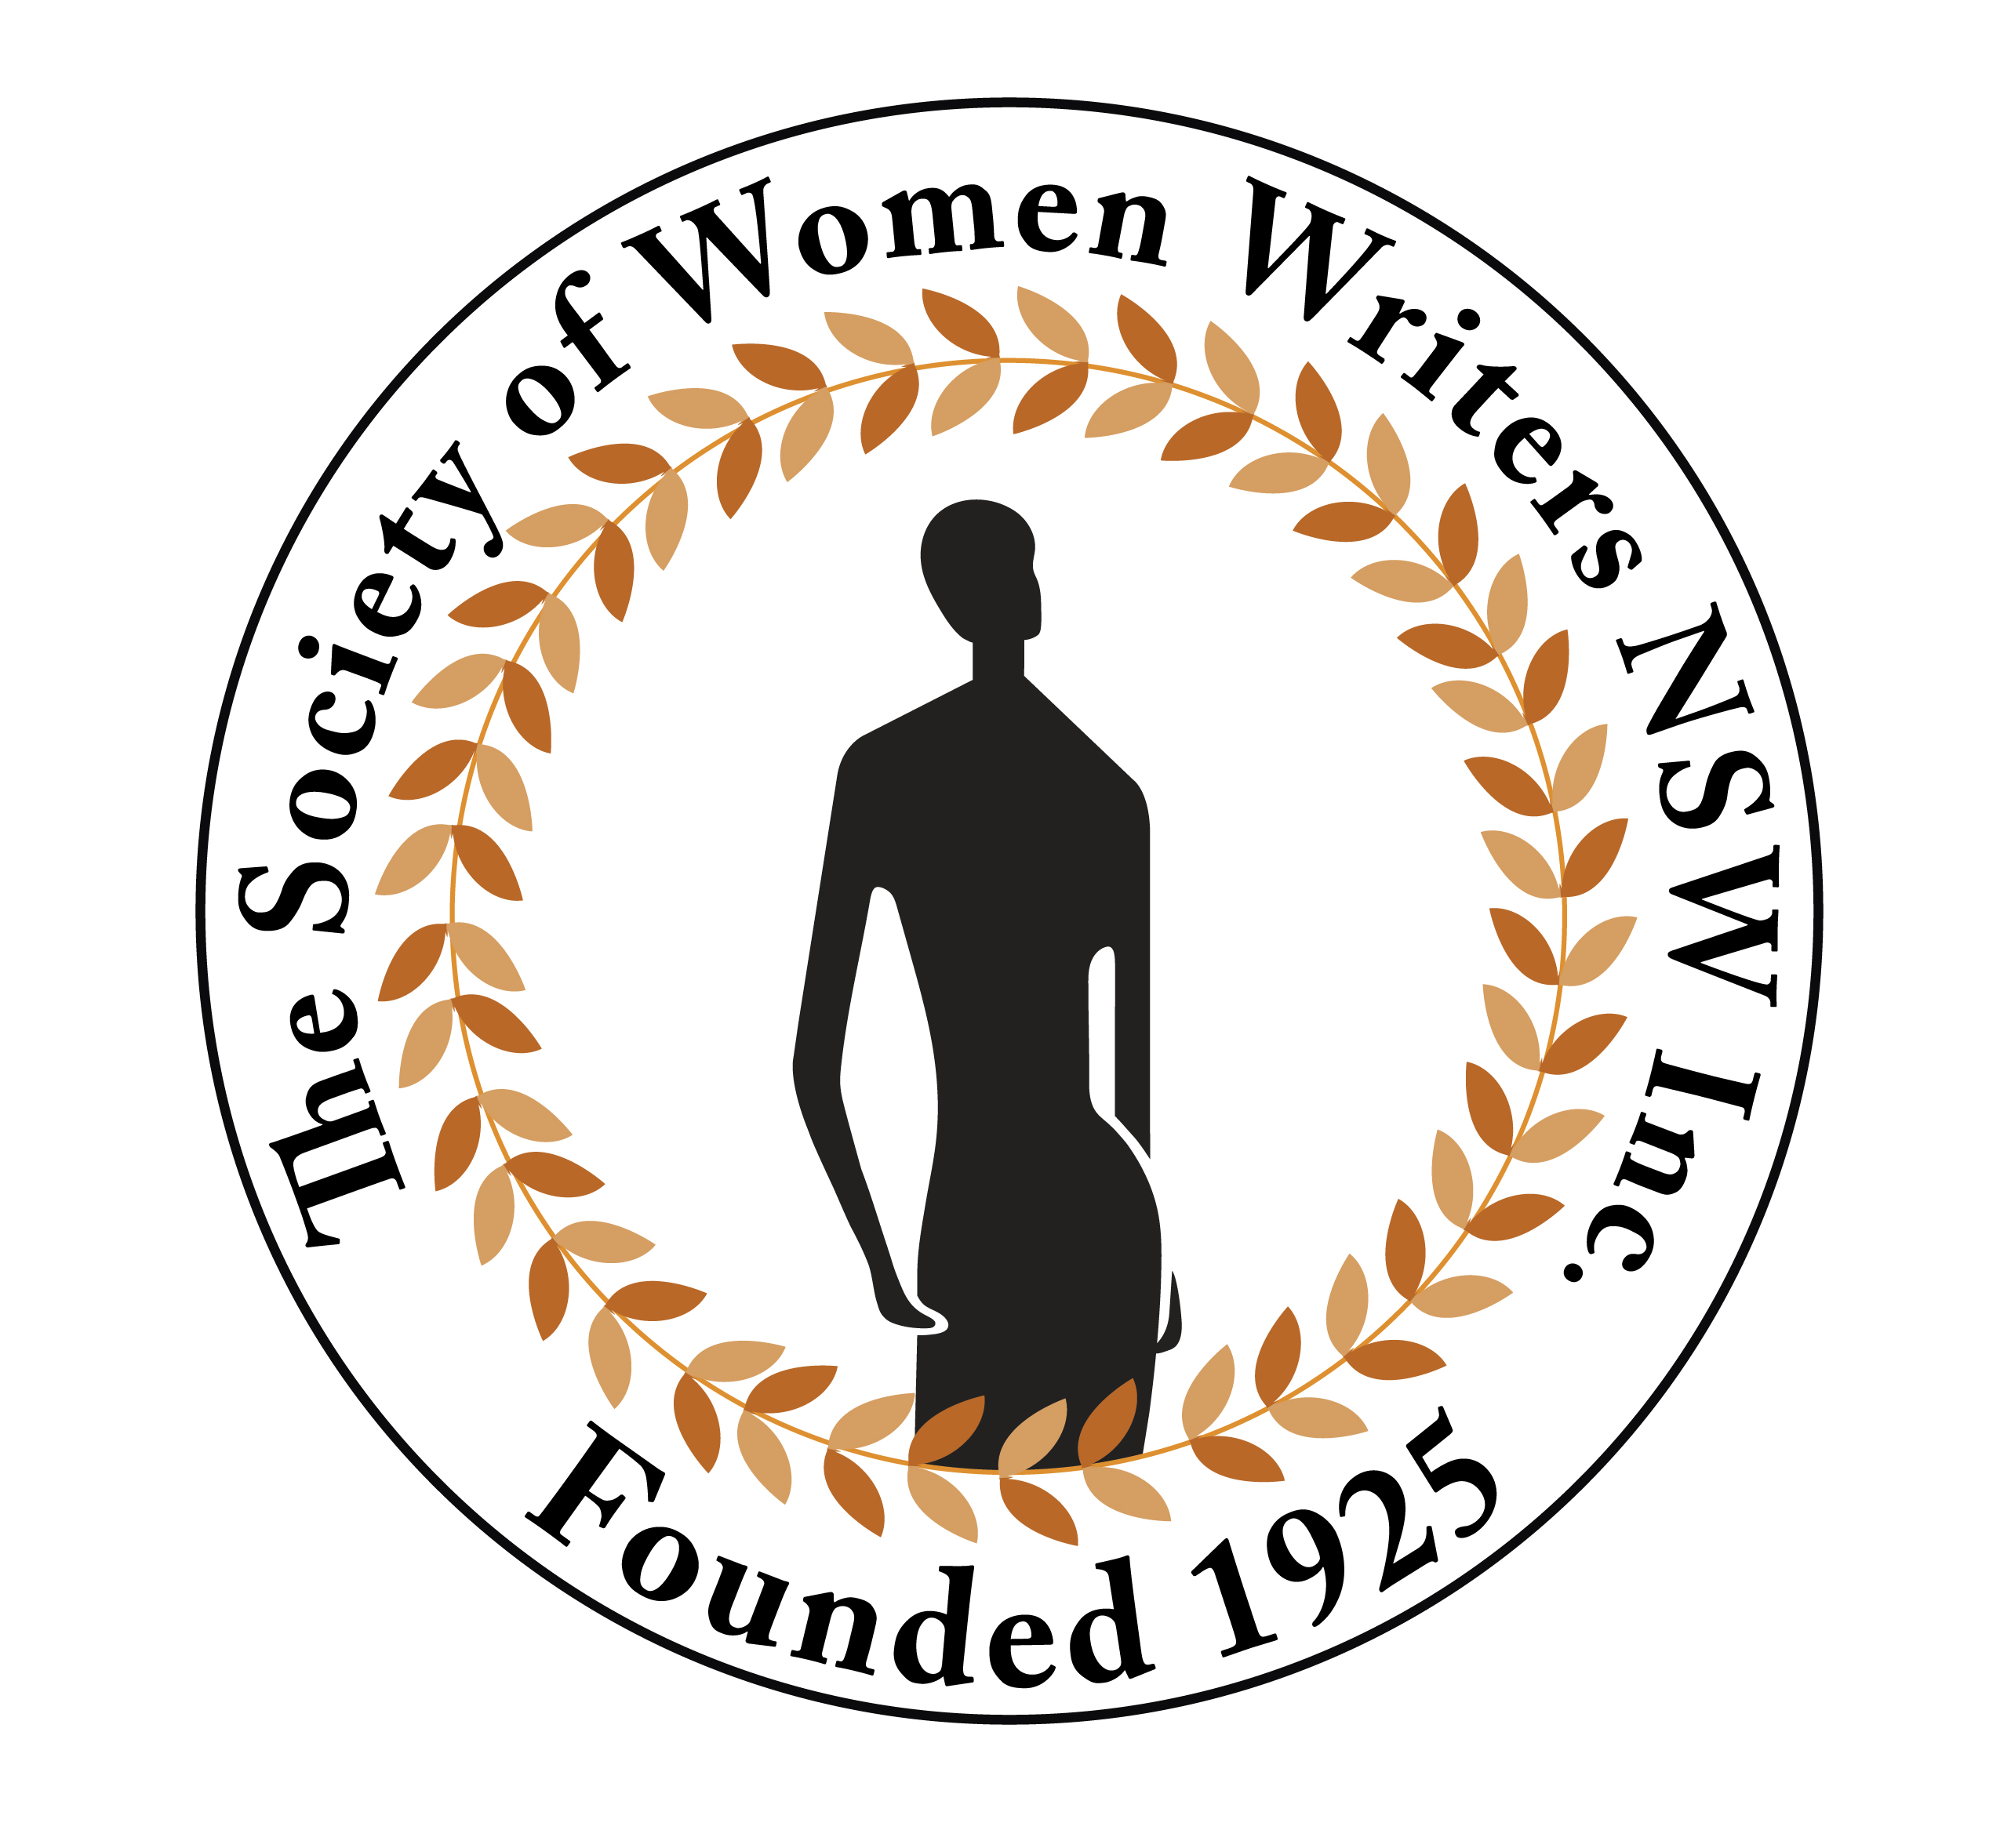

ABBIE CLANCY AWARD 2026
The Society of Women Writers was founded in 1925 by a group of women writers and journalists with the goal of supporting women writers and promoting Australian literature. Now, as the Society of Women Writers NSW, we sponsor competitions and awards for members as well as competitions open to all women writers.
The Award is named after Abigail Mary Clancy (1898-1984), one of the founders of The Society of Women Writers and a prominent early 20th century journalist. The Abbie Clancy Foundation Trust funds the Award and the Society sponsors the administration. This Award is open to female honours and post-graduate students attending universities in New South Wales and the Australian Capital Territory. Entrants for the Award of $1,000 must submit an abstract (300-500 words) of an unpublished research paper on the published or unpublished work(s) of fiction or non-fiction of an Australian woman writer, journalist, playwright or poet.
Conditions of entry: Submitted entries must be an abstract for an unpublished research paper on the published or unpublished work of an Australian woman writer, journalist, playwright or poet.
- Abstracts must be typed, 1.5 spaced, on one side of paper and must not exceed 500 words in length. The author’s name must not appear on the abstract.
- There is no limit to the number of entries a student may submit.
- Entries may be submitted via email OR mail.
- Entries must be received by 5.00 pm on Friday 31 July 2026.
- The winner will be notified by Friday 11 September 2026. The decision of the judge/s is final.
- The winner is required to present her paper (1,200 words) to The Society of Women Writers’ Literary Event on Wednesday 14 October 2026 in the Michael Crouch Room at the Mitchell Library.
- The Society of Women Writers retains first right of refusal of publication of the winner’s paper in its tri-annual magazine, Women’s Ink!
- Should entrants subsequently publish their papers elsewhere, The Society of Women Writers NSW Inc. and the Abbie Clancy Award must be acknowledged.
Additionally, the successful entrant has the opportunity to be nominated for sponsorship of $1,000 by the Society as the Abbie Clancy Awardee at the National Council of Women Australia Day Awards in January 2027.

Abbie Clancy Award enquiries to: Co-presidents, Pippa Kay and Liz Newton: swwpresident@gmail.com.

Email submission | Postal submission
Email attached entry form and abstract to:  swwpresident@gmail.com  Subject line: Abbie Clancy Award 2026 | Post entry form and abstract to:  Abbie Clancy Award 2026  The Society of Women Writers NSW Inc.  PO Box 1083, Hunters Hill 2110

The Society of Women Writers NSW Inc.
Giving Women Writers a Voice
Patron: Emeritus Professor Di Yerbury
www.womenwriters.org

ABBIE CLANCY AWARD 2026
ENTRY FORM

Name:
Postal Address:
Postcode
Email Address:
Telephone (H): Telephone (M):
Title of Abstract:

University:
Faculty:
Course:
Thesis title/topic (if applicable):

Name of Supervisor:
Supervisor’s Email Address:
Entries must be received by 5.00 pm on Friday 31 July 2026.
Entries may be submitted by either of the following methods:
Email submission | Postal submission
Email attached entry form and abstract to:  swwpresident@gmail.com  Subject line: Abbie Clancy Award 2026 | Post entry form and abstract to:  Abbie Clancy Award 2026  The Society of Women Writers NSW Inc.  PO Box 1083, Hunters Hill 2110

